

Name : PRAKASH REDDY

**Regd no :192111717**

**Subject : csa4053-MANAGEMENT INFORMATION**

**systems with commerce**

**1)aim:- To draw the USE CASE diagram for ATM SYSTEM**

**DIAGRAM:-**

**USECASE:-**

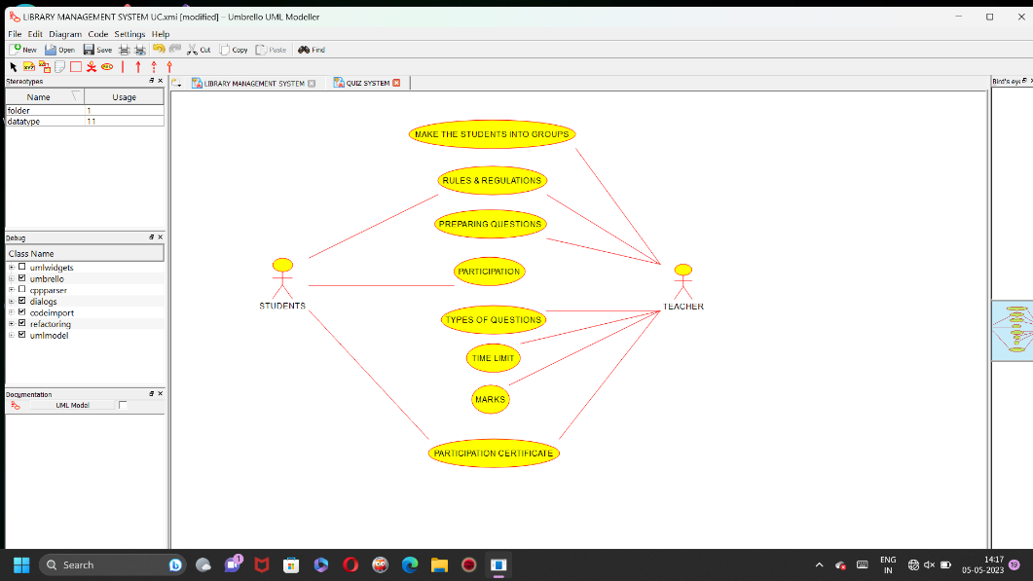

**2)aim:- To draw the UML diagram for ONLINE PURCHASING SYSTEM….**

**DIAGRAM:-**

**USECASE:-**

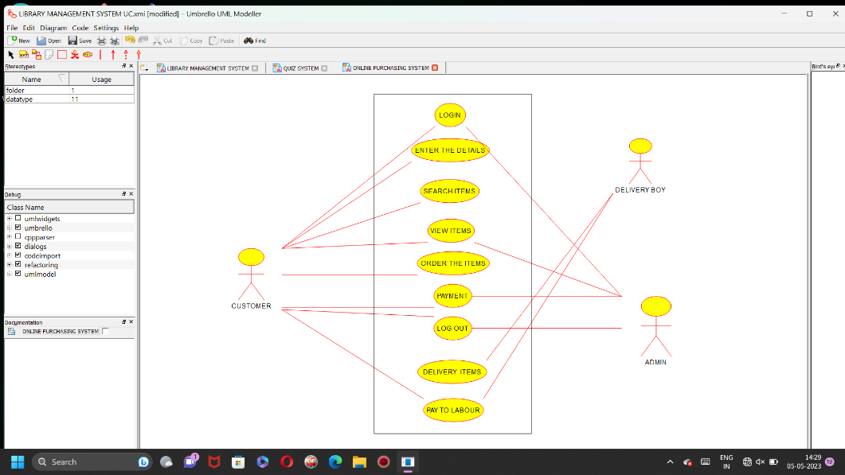

**3)aim:- To draw the UML diagrams for HOSPITAL MANAGEMENT SYSTEM …**

**DIAGRAM:-**

**USE DIAGRAM:-**

**The use cases and actors in use-case diagrams describe what the system does and how the actors use it, but not how the system operates internally.**

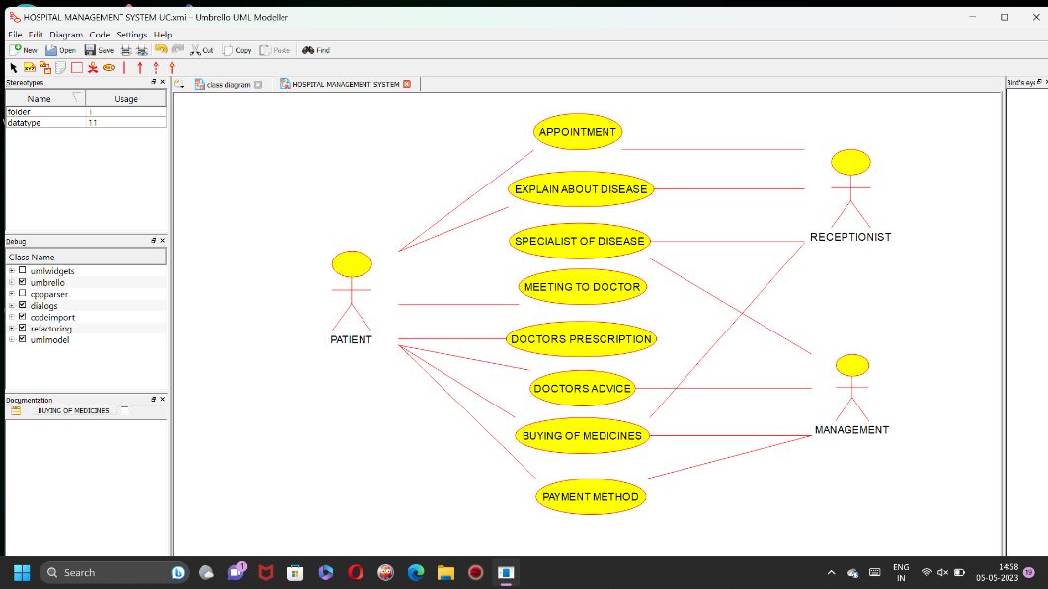

**4)aim:- To draw the CLASS diagram for ONLINE SECURITY MANAGEMENT SYSTEM..**

**CLASS DIAgRAM:-**

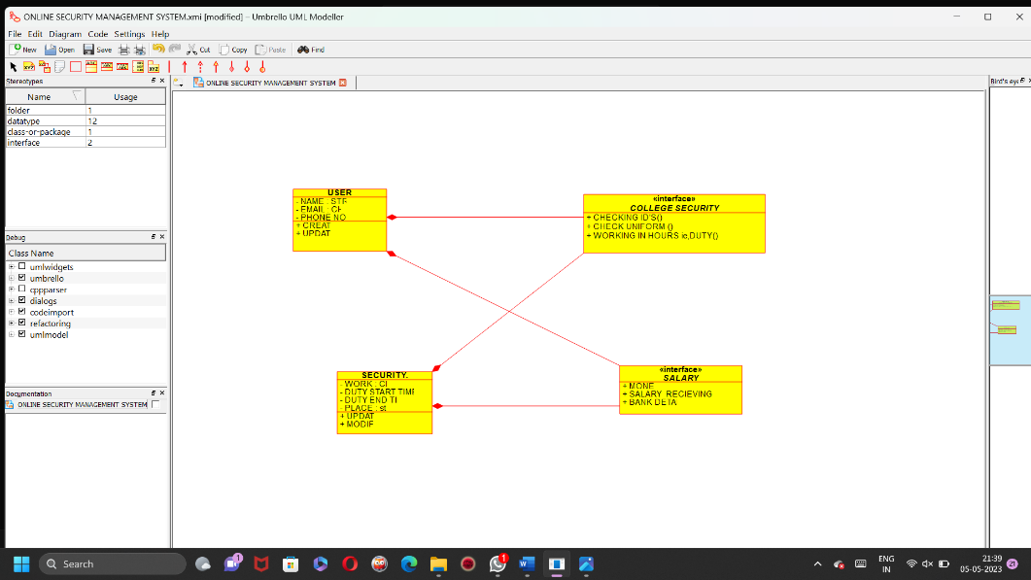

**5)aim:- To draw the USECASE diagram for LIBRARY MANAGEMENT SYSTEM..**

**USE CASE DIAGRAM:-**

